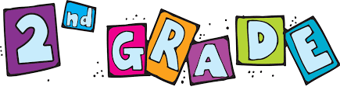
In Class Supplies (Labeled with Child’s Full Name)
- Supply Box – This needs to be small enough to fit inside a desk, but large enough to hold student’s belongings: Example
- Laptop Backpack OR Chromebook Sleeve (Example 1 and Example 2)
- Lunchbox & Reusable Water Bottle
- Headphones (Over the ear are preferred)
- 1 Plastic Folder
- 1 Wide Ruled Composition Notebook
- Thin Black Expo Markers (3 count)
- 1 Pack of 24 count Crayons
- 1 Pack of 10 count Washable Markers
- 1 Pack of 12 count Colored Pencils
- 1 Pair of Safety Scissors
- 3 Glue Sticks
- 1 Roll of Scotch Tape
- 1 Pack of Sharpened #2 Pencils
- 2 Pink Erasers
- 1 Set of Watercolor Paints with Brush (8 or 16 count)
- 1 Sketch Pad
- 1 Change of Clothes with Spare Mask in Zip Lock Bag
- Face Mask
- Folding camp chair for outside instruction – Example
2 boxes of Kleenex
- 1 bottle of hand sanitizer

At Home Supplies / Full-time Virtual Supply List
- Pencils & Erasers
- Paper
- Crayons, Markers, Colored Pencils
- Scissors, Glue, Tape
- Watercolor Paints
- Construction Paper
- Additional/Optional Items
- Construction Paper, Play Dough, Pipe Cleaners, Sidewalk Chalk, other art supplies.

